**CSC 1101 – Problem Solving and Programming Laboratory**

**Lab 8 – Omar Faruk**

**25 points – Due October 5, 11pm**

**a)** Save this document with your name and the homework number somewhere in the file name.

**b)** Paste your code and screenshots into the document.

**c)** Submit this document and your .cpp file(s) to the Canvas item where you downloaded this document. Do not submit a zip file but individually attach your files.

**1) [12 points]** You've been hired by *Maple Marvels* to write a C++ console application that displays information about the number of leaves that fell in September, October, and November. Prompt for and get from the user three integer leaf counts, one for each month. If any value is less than zero, print an error message and do nothing else. The condition to test for negative values may be done with one compound condition. If all values are at least zero, calculate the total leaf drop, the average leaf drop per month, and the months with the highest and lowest drop counts. The conditions to test for high and low values may each be done with two compound conditions. Use formatted output manipulators (setw, left/right) to print the following rows:

● September leaf drop

● October leaf drop

● November leaf drop

● Total leaf drop

● Average leaf drop per month

● Month with highest leaf drop

● Month with lowest leaf drop

And two columns:

● A left-justified label.

● A right-justified value.

Define constants for the number of months and column widths. Format all real numbers to three decimal places. The output should look like this for invalid and valid input:

55

Welcome to Maple Marvels

------------------------

Enter the leaf drop for September: 40

Enter the leaf drop for October: -100

Enter the leaf drop for November: 24

Error: all leaf counts must be at least zero.

End of Maple Marvels

Welcome to Maple Marvels

------------------------

Enter the leaf drop for September: 155

Enter the leaf drop for October: 290

Enter the leaf drop for November: 64

September leaf drop: 155

October leaf drop: 290

November leaf drop: 64

Total drop: 509

Average drop: 169.667

Highest drop: October

Lowest drop: November

End of Maple Marvels

Do not use this sample input for the final runs pasted below.

*[your program code here]\**

//==========================================================

//

// Title: Leaf Drop Calculator

// Course: CSC 1101

// Lab Number: Lab 08-01

// Author: Omar Faruk

// Date: 10/05/20

// Description:

// Using inputs create a formatted output

// and using if else statements.

//

//==========================================================#include <cstdlib> // For several general-purpose functions

#include <fstream> // For file handling

#include <iomanip> // For formatted output

#include <iostream> // For cin, cout, and system

#include <string> // For string data type

using namespace std; // So "std::cout" may be abbreviated to "cout"

int main()

{

// Declare constants

const int COLMFT1 = 35;

const int COLMFT2 = 15;

const string sept = "September";

const string nov = "November";

const string oct = "October";

//Declare Variables

int total_drop;

float average_drop;

int septLeaf;

int octLeaf;

int novLeaf;

// Show application header

cout << "Welcome to Maple Marvels!" << endl;

cout << "--------------------------" << endl << endl;

cout << fixed << setprecision(3);

// Write to screen

cout << setw(COLMFT1) << left << "Enter the leaf drop for September:";

cin >> septLeaf;

cout << setw(COLMFT1) << left << "Enter the leaf drop for October:";

cin >> octLeaf;

cout << setw(COLMFT1) << left << "Enter the leaf drop for November:";

cin >> novLeaf;

if (septLeaf < 0)

cout << "Error: all leaf count must be at least zero."

<< endl;

else if (octLeaf < 0)

cout << "Error: all leaf count must be at least zero."

<< endl;

else if (novLeaf < 0)

cout << "Error: all leaf count must be at least zero."

<< endl;

else

{

//Calculation

total_drop = (septLeaf + octLeaf + novLeaf);

average_drop = septLeaf + octLeaf + novLeaf / 3;

cout << endl;

cout << setw(COLMFT1) << left << "September leaf drop:";

cout << setw(COLMFT2) << right << septLeaf << endl;

cout << setw(COLMFT1) << left << "October leaf drop:";

cout << setw(COLMFT2) << right << octLeaf << endl;

cout << setw(COLMFT1) << left << "November leaf drop:";

cout << setw(COLMFT2) << right << novLeaf << endl;

cout << setw(COLMFT1) << left << "Average drop:";

cout << setw(COLMFT2) << right << average_drop << endl;

cout << setw(COLMFT1) << left << "Total drop:";

cout << setw(COLMFT2) << right << total_drop << endl;

cout << setw(COLMFT1) << left << "Highest drop:";

if (septLeaf > octLeaf && septLeaf > novLeaf)

cout << setw(COLMFT2) << right << sept;

else if (octLeaf > novLeaf && octLeaf > septLeaf)

cout << setw(COLMFT2) << right << oct;

else

cout << setw(COLMFT2) << right << nov;

cout << endl;

cout << setw(COLMFT1) << left << "Lowest drop:";

if (septLeaf < octLeaf && septLeaf < novLeaf)

cout << setw(COLMFT2) << right << sept;

else if (octLeaf < novLeaf && octLeaf < septLeaf)

cout << setw(COLMFT2) << right << oct;

else

cout << setw(COLMFT2) << right << nov;

}

// Show application close

cout << "\nEnd of Maple Marvels" << endl;

}

*[your program output for two runs here – one with invalid input and one with valid input]\*\**

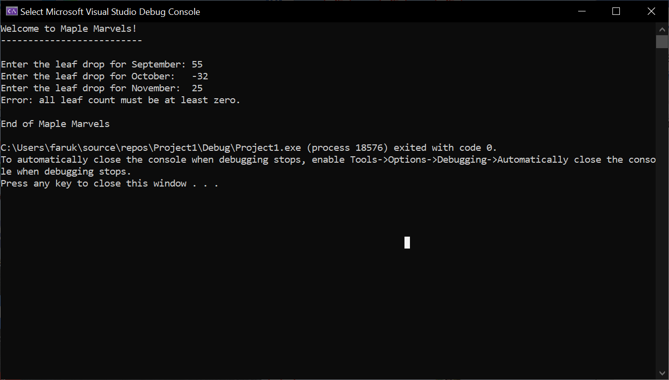

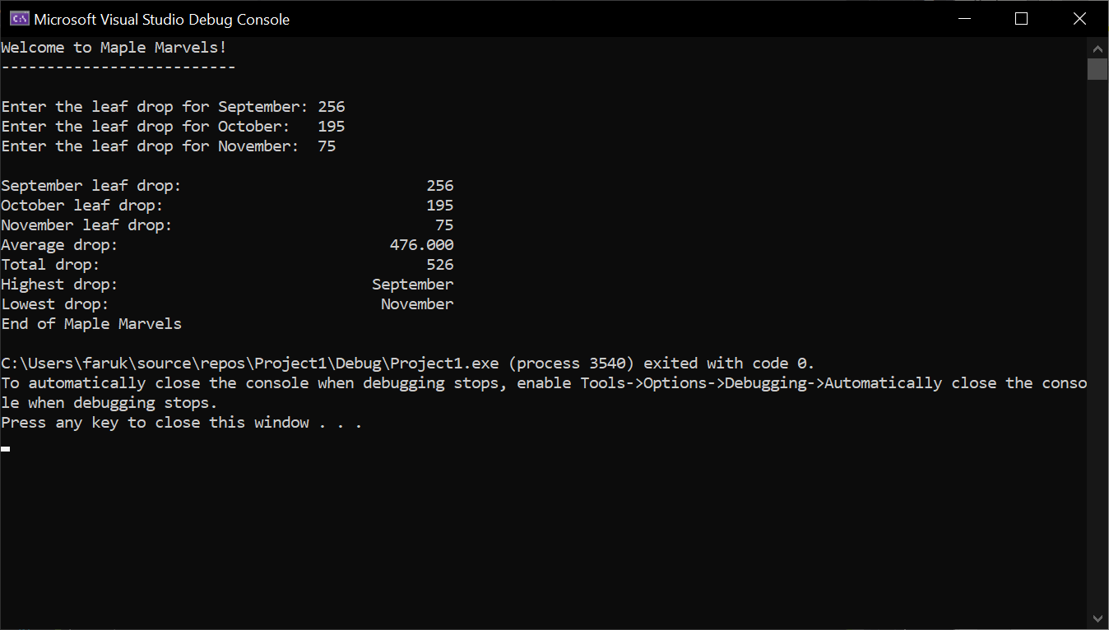

**2) [13 points]** You've been hired by *Office Oaks* to write a C++ console application that calculates and displays the cost of a customer’s purchase of one item. Prompt for and get from the user the quantity of the item purchased in the range 2-20. If the value is outside the range, print an error message and do nothing else. If the value is within the range, prompt for and get from the user a product character code per the following table:

|  |  |  |
| --- | --- | --- |
| Code | Product | Cost |
| **c** | Clipboards (pack of 3) | $8.00 |
| **p** | Printer paper (3 reams) | $15.00 |
| **r** | Scissors (pack of 2) | $10.75 |
| **s** | Stapler | $11.25 |
| **w** | Writing pads (dozen) | $12.50 |

Use an **if** or **switch** statement to determine which code was entered. Variables to store the product name and cost for use after the if/switch statement may be used. Assume a code of 'w' if the user didn't enter one of the five codes. Calculate the subtotal of the purchase. If the subtotal is greater than $50, give the customer a discount of 10%. Then calculate the total after the discount. Use formatted output manipulators (setw, left/right) to print the following rows:

● Product code

● Product name

● Product cost ($)

● Quantity

● Subtotal ($)

● Discount ($)

● Total ($)

And two columns:

● A left-justified label with units.

● A right-justified value.

Define constants for each of the five product costs, the discount minimum ($50), the discount rate (.1), and the column widths. Format all real numbers to two decimal places. The output should look like this for invalid and valid input:

Welcome to Office Oaks

----------------------

Enter quantity purchased in range 2 and 20: 24

Error: quantity purchased must be in range 2 and 20.

End of Office Oaks

Welcome to Office Oaks

----------------------

Enter quantity purchased in range 2 and 20: 4

Enter the product code

c-Clipboards,

p-Printer paper,

r-Scissors,

s-Stapler,

w-Writing pads

: p

Product code: p

Product name: Printer paper

Product cost ($): 15.00

Quantity: 4

Subtotal ($): 60.00

Discount ($): 6.00

Total ($): 54.00

End of Office Oaks

Do not use this sample input for the final runs pasted below.

*[your program code here]\**

//==========================================================

//

// Title: Sales Calculator

// Course: CSC 1101

// Lab Number: Lab08-02

// Author: Omar Faruk

// Date: 10/05/2020

// Description:

// Creating a Sales calculator with discount factored in.

// Used if and else statements, formatted table, and and calculations.

//

//==========================================================

#include <cstdlib> // For several general-purpose functions

#include <fstream> // For file handling

#include <iomanip> // For formatted output

#include <iostream> // For cin, cout, and system

#include <string> // For string data type

using namespace std; // So "std::cout" may be abbreviated to "cout"

int main()

{

//Format Real Numbers

cout << fixed << setprecision(2);

//Declare Constants

const int COLMFT1 = 40;

const int COLMFT2 = 15;

const double CLIPBOARDS = 8.00;

const double PRINTER_PAPER = 15.00;

const double SCISSORS = 10.75;

const double STAPLER = 11.25;

const double WRITING_PADS = 12.50;

const int DISCOUNT_MIN = 50;

const double DISCOUNT_RATE = .1;

const string clip_board = "Clipboards";

const string printer_paper = "Printer paper";

const string stapler = "Stapler";

const string writing_pads = "Writing pads";

const string scissors = "Scissors";

// Declare variables

char code;

int quantity;

double product_cost;

double subtotal;

double discount;

double total;

string product_name;

// Show application header

cout << "Welcome to Office Oaks!" << endl;

cout << "--------------------------" << endl << endl;

// Write to screen

cout << setw(COLMFT1) << left << "Enter quantity purchased in range 2 and 20: ";

cin >> quantity;

if (quantity < 2 || quantity > 20)

cout << "Error: quantity purchased must be in range 2 and 20." << endl;

else

{

// Product code IO

cout << "\nEnter the product code" << endl;

cout << " c-Clipboards," << endl;

cout << " p-Printer paper," << endl;

cout << " r-Scissors," << endl;

cout << " s-Stapler," << endl;

cout << " w-Writing pad," << endl;

cin >> code;

if (code == 'c')

product_name = clip_board;

else if (code == 'p')

product_name = printer_paper;

else if (code == 'r')

product_name = scissors;

else if (code == 's')

product_name = stapler;

else if (code == 'w')

product_name = writing_pads;

else

{

(product_name = writing_pads);

}

cout << setw(COLMFT1) << left << "\nProduct Code: ";

cout << setw(COLMFT2) << right << code << endl;

cout << setw(COLMFT1) << left << "Product name: ";

cout << setw(COLMFT2) << right << product_name << endl;

if (code == 'c')

product_cost = CLIPBOARDS;

else if (code == 'p')

product_cost = PRINTER_PAPER;

else if (code == 'r')

product_cost = SCISSORS;

else if (code == 's')

product_cost = STAPLER;

else if (code == 'w')

product_cost = WRITING_PADS;

else

{

(product_cost = WRITING_PADS);

}

//Product cost & quantity Output

cout << setw(COLMFT1) << left << "Product cost ($): ";

cout << setw(COLMFT2) << right << product_cost << endl;

cout << setw(COLMFT1) << left << "Quantity: ";

cout << setw(COLMFT2) << right << quantity << endl;

//Calculation

subtotal = (quantity * product_cost);

if (subtotal > DISCOUNT_MIN)

discount = (subtotal * DISCOUNT_RATE);

else (discount = 0);

total = (subtotal - discount);

//Product total Output

cout << setw(COLMFT1) << left << "Subtotal ($): ";

cout << setw(COLMFT2) << right << subtotal << endl;

cout << setw(COLMFT1) << left << "Discount ($): ";

cout << setw(COLMFT2) << right << discount << endl;

cout << setw(COLMFT1) << left << "Total ($): ";

cout << setw(COLMFT2) << right << total << endl;

}

// Show application close

cout << "\nEnd of Office Oaks" << endl;

}

*[your program output for two runs here – one with invalid input and one with valid input]\*\**

